MODULE 4

Que 1
https://www.hackerearth.com/problem/algorithm/digit-sum-4/

Code
#include <stdio.h>

int main(){
int t;
scanf("%d", &t);
while (t--) {
long long n;
scanf("%lld", &n);
int last_digit = n % 10;
int first_digit = n;
while (first_digit >= 10) {
first_digit/=10;}
long long sum = first_digit + last_digit;
printf("%lld\n", sum);}
return 0;
}

Output
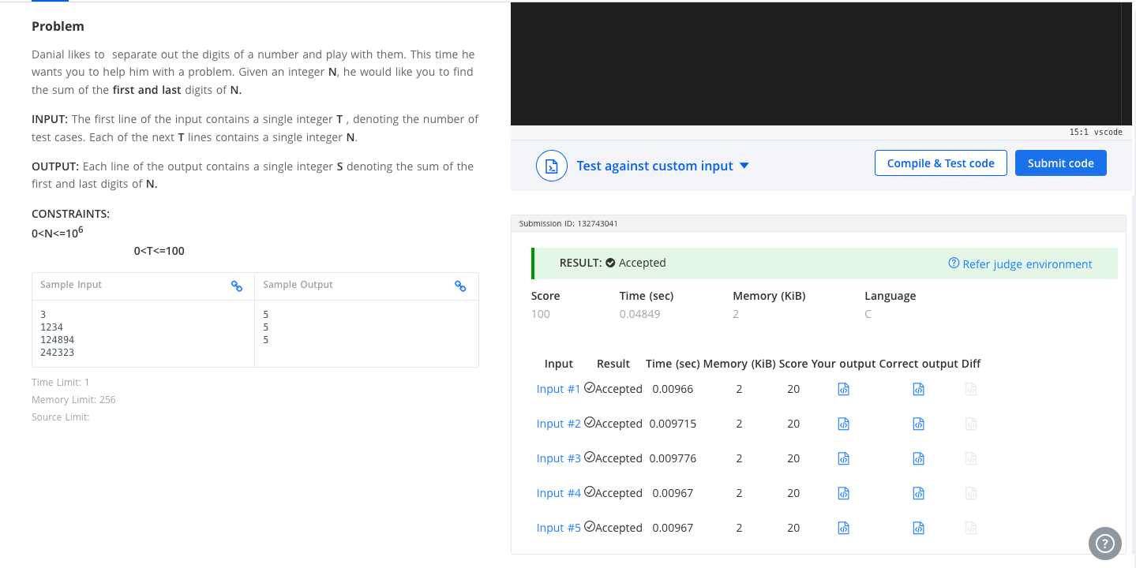

Que 2
https://www.hackerrank.com/challenges/find-digits/problem
Code
int findDigits(int n) {
int count = 0;
int temp = n;

while (temp > 0) {
int digit = temp % 10;

if (digit != 0 && n % digit == 0) {
count++;
}

temp = temp / 10;
}

return count;
}

Output
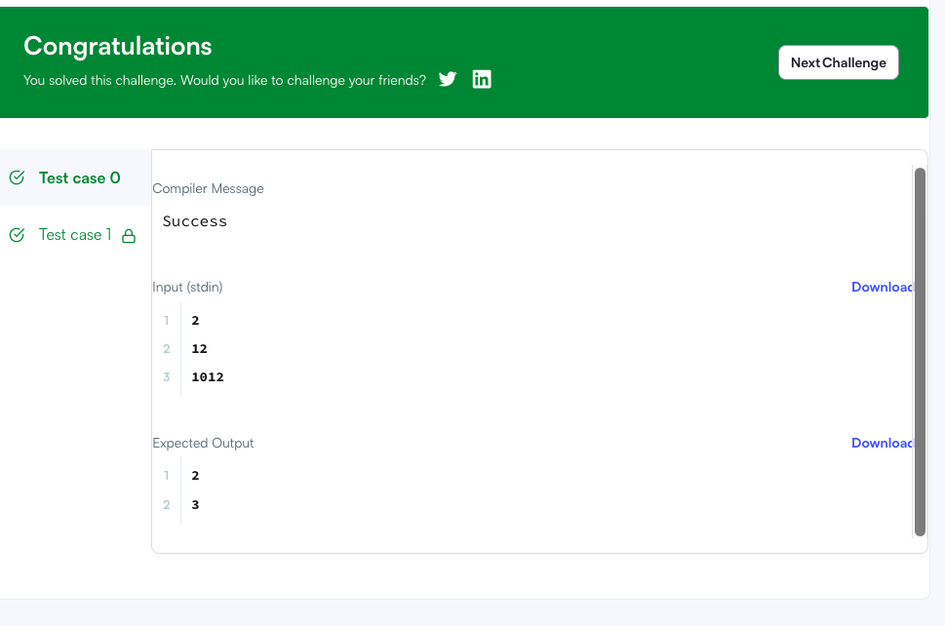

Que 3
https://leetcode.com/problems/subtract-the-product-and-sum-of-digits-of-an-integer/description/

Code
int subtractProductAndSum(int n) {
int product = 1;
int sum = 0;

while (n > 0) {
int digit = n % 10;
product *= digit;
sum += digit;
n /= 10;
}

return product - sum;
}

Output
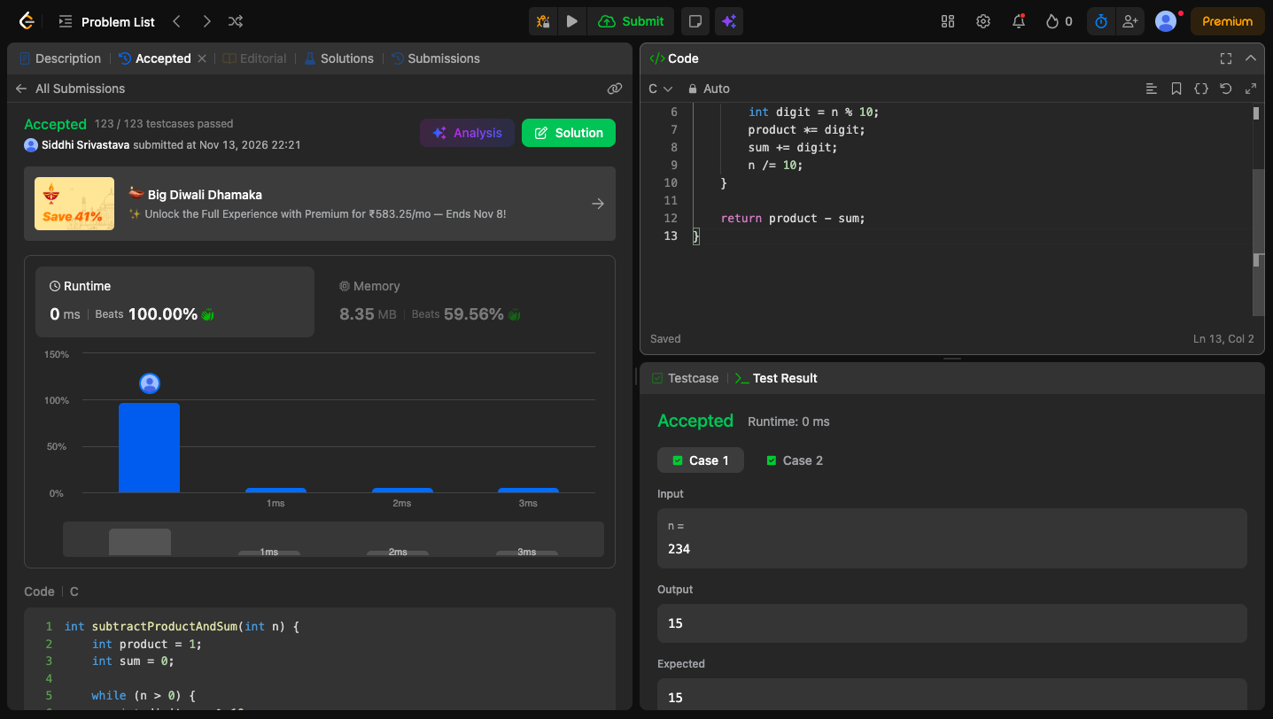

Que 4
https://leetcode.com/problems/count-the-digits-that-divide-a-number/description/

Code

input countDigits(int num) {
int count = 0;
int original = num;

while (num > 0) {
int digit = num % 10;
// Check if digit divides the original number evenly
if (original % digit == 0) {
count++;
}
num /= 10;
}

return count;
}


Output
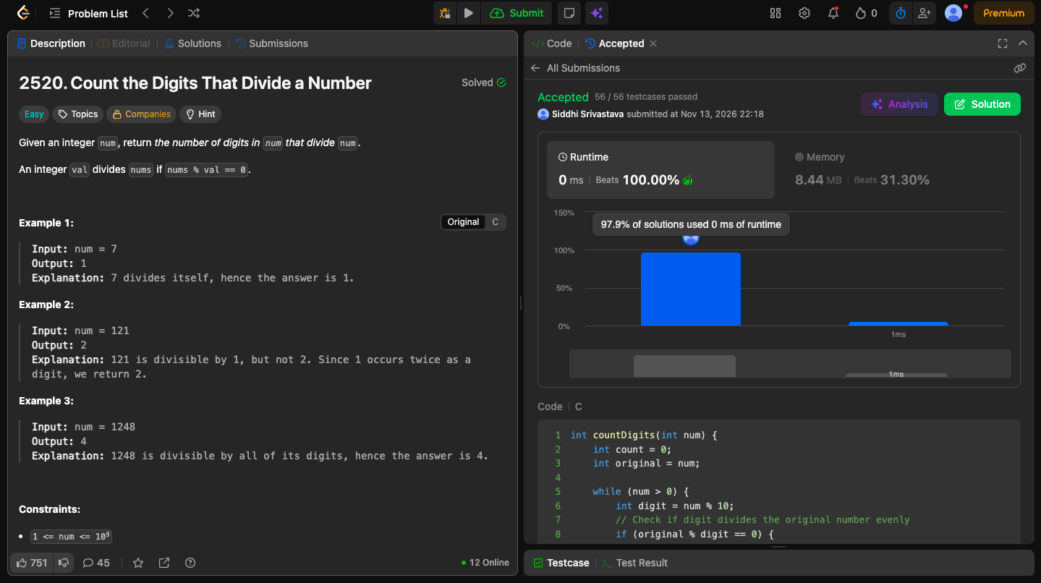

Que 5 https://leetcode.com/problems/palindrome-number/description/
Code
bool isPalindrome(int x) {

if (x < 0 || (x % 10 == 0 && x != 0)) {
return false;
}

int reversed_half = 0;
while (x > reversed_half) {
reversed_half = reversed_half * 10 + x % 10;
x /= 10;
}
return x == reversed_half || x == reversed_half / 10;
}

Output


